2024 Scouts, BSA Program Guide

CAMP CORNHUSKER
www.cornhuskercouncil.org/camping/camp-cornhusker/

TABLE OF CONTENTS

TOPIC PAGE NUMBER

Welcome 3
Camp Administration 4
Summer 2024 Theme 5
General Information 6
Merit Badge/Schedule Information 7
Merit badge Schedule/Swim Checks 8
General Merit Badge Information 9-14
Opportunities for Older Scouts 15
Cornhusker’s Sharp Shooters/C.O.P.E. 16
TTFC 17
Mountain Man 18-19
Campwide Games and Activities 20-23
Order of the Arrow 24
Adult Leader Opportunities 25
Training Opportunities 26
Camp Equipment 27
Staffing at Camp Cornhusker 28
Cornhusker Honor Camper/ Scoutmaster Merit Badge 29-30

Dear Scouting Family,

As your Program Director, it is my absolute pleasure to welcome you and your unit to the 2024 camping season at Camp Cornhusker!

Sixteen years ago, I started serving on summer camp staff at Camp Bob Hardin in Saluda, North Carolina. After seven years there, the Scouting Program took me to Alaska to continue serving our youth. After two years in Alaska, the Scouting Program brought me here to Camp Cornhusker, where I have had the privilege to serve as Program Director for the past seven summers.

We have been listening to your thoughts and concerns as we look over every evaluation. The leadership team has been hard at work planning and prepping with our staff members to run the best program we can for all our Scouts and Scouters. We have spent countless hours looking over each part of our summer camp experience. This begins with our check-in process on Sunday to our checkout process on Saturday and everything in between. We are committed to delivering the best camp experience around!

I am humbled to be able to serve as your Program Director and I commit to you that I will work tirelessly to ensure that each person who comes through our front gates, whether returning to Cornhusker or entering for the first time, has a memorable experience.

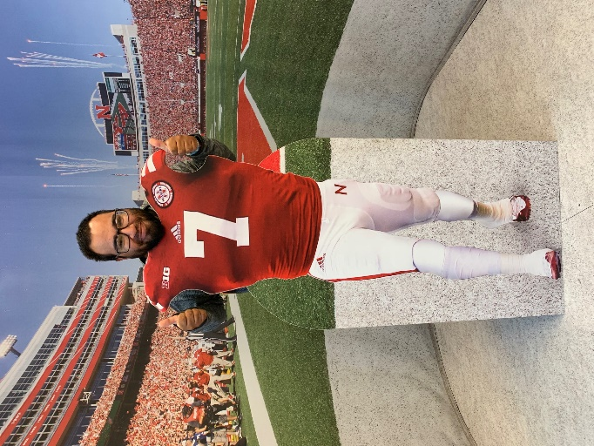
Out of all of my travels, Camp Cornhusker has become my “home away from home”. From the minute I stepped foot on the property seven years ago, I have had the time of my life developing program and serving youth and adults! To those who are returning to Camp Cornhusker, “Welcome Home.” To those joining us for the first time, it is my hope that Camp Cornhusker becomes “your home away from home”!

I look forward to seeing everyone at camp this summer!

Yours in Scouting,

Thomas Bucks Program Director
cornhuskerprogramdirector@gmail.com

*Please note that the Leader’s Guide for Camp 2024 will include final schedules and the final merit badge listing*

P.S. Go Big Red!

Meet your Camp Administration

Camp Director
I am Samantha (Sammi) Lowery, Camp Cornhusker’s Camp Director. I worked at Cornhusker the summers of 2008 through 2012 in various positions from C.O.P.E. Instructor to Webelos Camp Director. I am a Brotherhood member of the Order of the Arrow and have gone through Wood Badge as a proud Antelope! This will be my seventh summer returning to Cornhusker and I am glad to be home!
I am a science teacher at Lincoln Southeast High School where I teach biology, chemistry, and forensic science. I am also a volunteer assistant softball coach at Lincoln East. I live in Lincoln, Nebraska with my husband, Stephen Lowery, our sons, Thomas, Charles, and Oliver, and our puppy Murphy. I am excited for the opportunity to be back at Camp Cornhusker and look forward to working with all of you!
This summer will be another fantastic camping season. Please note that this packet contains all of the overall program details for summer 2024. The Leader’s Guide contains scheduling and important camp information.

Co-Camp Director
I am Shannon LeFave, Camp Cornhusker’s Co-Camp Director. I have served as a staff member for several years and before that came to camp as a troop leader, pack leader and/or parent since 2010. When I am not scouting I teach junior and senior high school science and coach. Currently I serve as a Scoutmaster for my local troop and am a member of the Order of the Arrow. As a youth and adult, I have participated in many scouting activities, camps, and two jamborees. I look forward to providing you a great scouting experience. I hope that this program guide helps you through the process of preparing and attending Camp Cornhusker.

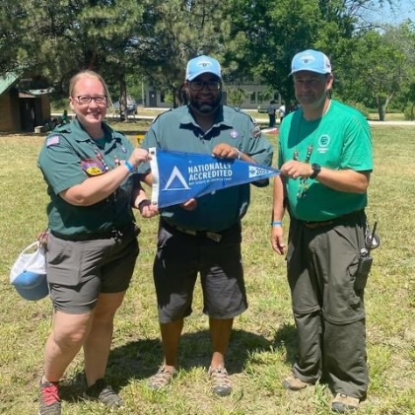
Program Director
My name is Thomas Bucks and this is my seventh year as Program Director. I am an Eagle Scout and a Brotherhood member of the Order of the Arrow. This is my sixteenth summer on camp staff.

Head Commissioner
Our Commissioner will be a great connection between the Troops and the Camp Administration.

2024 Camp Theme: Scouting Spirit

Each day we’ll have a different theme to dress up to for that day

Monday: Western Day

Start the week off with a root’n tootn’ good time!

Tuesday: Hawaiian Day

Grab your Hawaiian shirt & your lei!

Wednesday: Comic Book Day

Are you the Hero or Villain of your comic story?

Thursday: Decades Day

Time to hit Mom & Dad’s closet to find an outfit older than you!

Friday: Neon Day

Glow out as we finish the final day of camp!

CAMP CORNHUSKER 2024 SCHEDULE
 | Starting | Ending
Staff Week | June 2, 2024 | June 8, 2024
Scouts BSA Week 1 | June 9, 2024 | June 15, 2024
Scouts BSA Week 2 | June 16, 2024 | June 22, 2024
Adventure Week 3- see separate guide | June 30th, 2024 | July 6th, 2024

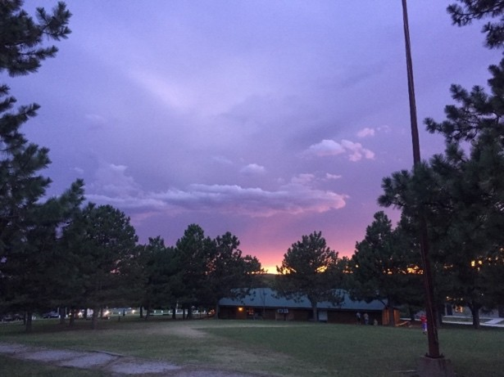

The Summer Camp Experience
A summer camp experience in the making since 1956, this program isn’t just the most fun your scouts will have all summer, it’s an invaluable opportunity for learning, growth, and personal development. Our enthusiastic and knowledgeable staff are the ideal guides through a week of campfires, merit badges, songs, and much more!
BSA Mission Statement
The mission of the Boy Scouts of America is to prepare young people to make ethical and moral choices over their lifetimes by instilling in them the values of the Scout Oath and Law.
Camp Accreditation
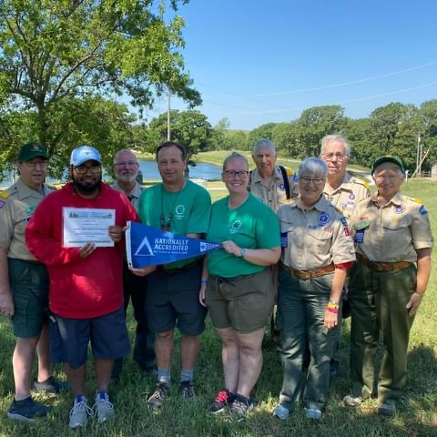
Each summer, Camp Cornhusker goes through a rigorous accreditation process from the National Camp Accreditation Program. This means that the camp has met strict guidelines in health, safety, and programming.

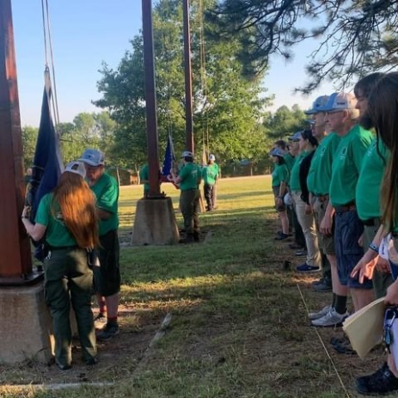
Camp Cornhusker Staff Vision

If the camp were a body, then the staff would be its beating heart. The staff are the vital lifeblood of this camp and they are planning to go above and beyond once again for your Scouts. This year has a dedicated and unique group of Scouts and Scouters who cannot wait to provide a quality week of summer camp for you and your Scouts.

Merit Badge Program
Weather Impact on Program/Activities
Occasionally, severe weather may affect camp programming and activities. Aquatics, C.O.P.E., and Shooting Sports areas are often the first areas impacted. Thunder and lightning near camp can cause us to “delay” or “cancel” these activities. All decisions made by the Camp Administration are to ensure camper safety, as our first priority is to keep everyone on property safe.

Merit Badge Reports

Adult Leaders will be able to log into your Black Pug registration and check merit badge progress daily. Requirements are uploaded after dinner. On Thursday night a Merit Badge Roundtable will be held to go over any requirements needed to be completed during make-up time on Friday morning.

Daily Schedule

7:15 AM | Assembly and KP Call
7:20 AM | Flag Ceremony – Flag is Raised
7:30 AM | Breakfast
8:45 AM – 10:00 AM | Merit Badge Session 1
10:15 AM – 11:30 AM | Merit Badge Session 2
12:00 PM- 1:00 PM | Lunch
1:15 PM – 2:30 PM | Merit Badge Session 3
2:45 PM – 4:00 PM | Merit Badge Session 4
4:15 PM – 5:30 PM | Open Areas
6:00 PM – 7:00 PM | Dinner (except Wednesday- Cook-in Campsite)
7:15 PM – 9:00 PM | Open Areas/ Evening Activity

Open Areas/Evening Programs vary by day – Check current session calendar for details and leader trainings.

Hourly Merit Badge Schedule
Merit Badges are offered during each session Monday-Thursday. Friday morning is used for troop time or Merit-Badge make-up time.
Session 1: 8:45 – 10:00 AM
Session 2: 10:15 AM – 11:30 AM
Session 3: 1:15 PM – 2:30 PM
Session 4: 2:45 PM – 4:00 PM

Sessions are 75 minutes in length with 15 minutes between sessions so Scouts can get to their next activity on time. Some merit badges and activities span multiple sessions. As a result, someone signed up for C.O.P.E., Environmental Science Merit Badge, or Trail to First Class will need to be aware of the schedule.
Scoutmasters will be able to sign-up for merit badges and activities beginning no earlier than January 1, 2024. Merit badges and other activities each have a maximum enrollment based on facility, equipment, and instruction limitations, so it is important that Scouts sign up for the merit badges and activities they want to participate in as soon as possible.
This schedule will allow Scouts to complete their merit badges and receive fewer partials at the end of your week at Camp. We hope that you and your Scouts will benefit from this scheduling. For some merit badges, additional time may be needed to be spent observing, practicing, or involved in project work. It is imperative for each Scout to check- in to their merit badges to receive credit for the work they complete.

Swim Check

All Scouts and Leaders attending Summer Camp must take the Scouts BSA swim check to enter the water. The swimming ability of all Scouts and leaders must be evaluated annually before they can take part in any aquatics activity, per BSA policy as contained in the Guide to Safe Scouting.

The unit may also hold their own “unit swim check” in accordance with B.S.A. Standards, https://filestore.scouting.org/filestore/outdoor%20program/aquatics/pdf/430-122.pdf. Units that have already completed their swim checks before arrival to camp should present a copy of the results to the Aquatics Director. The aquatics staff reserves the right to re-check any Scout at camp.

This can really streamline your Sunday afternoon!

Any Scouts or Leaders that didn’t do an early swim test will do so on Sunday. Upon completion of your swim test the appropriate buddy tag will be placed on the out-board. All scouts and leaders will be classified according to their swimming ability on the following scale: non-swimmer (white), beginner (red), and swimmer (blue).

**To participate in any aquatics merit badges or activities, scouts must complete the Swim Test prior to arriving at their selected classes. **

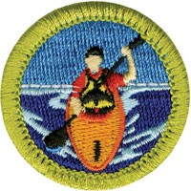
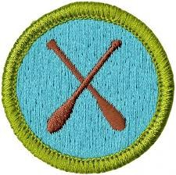
Program Areas
Cornhusker has several different program areas where Scouts can complete merit badges, hone their Scout Skills, and have fun. These areas include Aquatics, Outdoor Skills, Health, Shooting Sports, Ecology & Conservation, Life Skills, and Handicraft. Make sure you leave some open time in your schedule to enjoy all that we have to offer!

Aquatics
Aquatics is always one of the most popular program areas at any summer camp. With a wide selection of merit badges and program opportunities, almost every Scout is sure to visit the waterfront at least once during their stay.

Merit Badges
- Swimming MB
- Kayaking MB
- Canoeing MB
- Small Boat Sailing MB
- Lifesaving MB
- Rowing MB

Activities
- BSA Stand-up Paddle Boarding
- Instructional Swim
- Snorkeling

Open Program
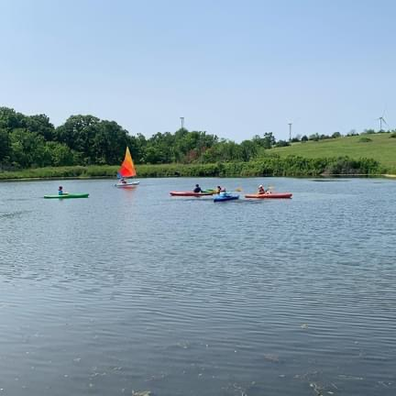
- Open Pool
- Open Lake

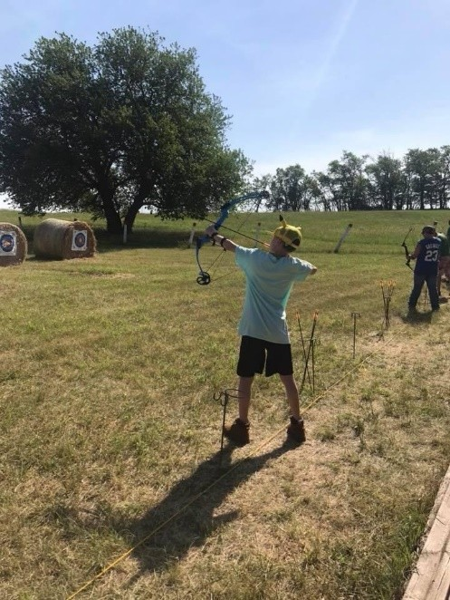
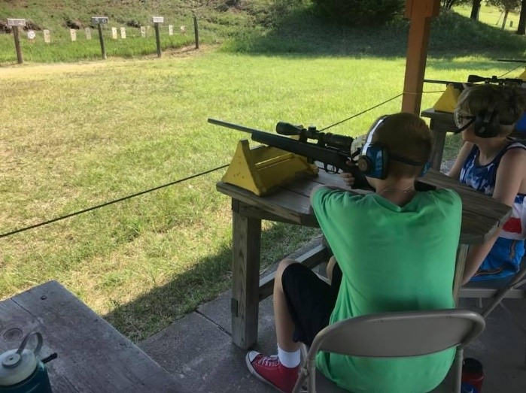
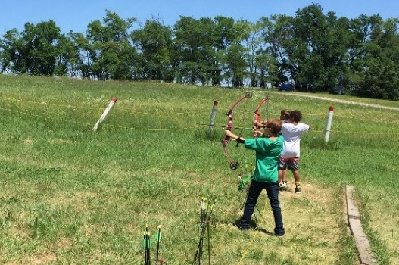
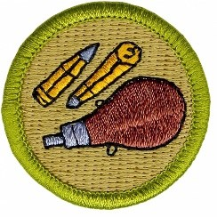
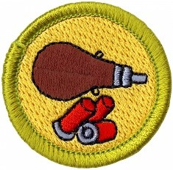
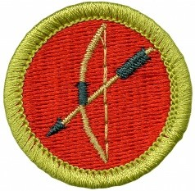
Shooting Sports
A good Shooting Sports area is important for all Scout camps. At Cornhusker, we are proud of our shooting sports program and hope that every scout and leader take the time to visit!

Merit Badges
- Rifle
- Shotgun (AM ONLY)
- Archery

Open Program
- Daily Open Shoot

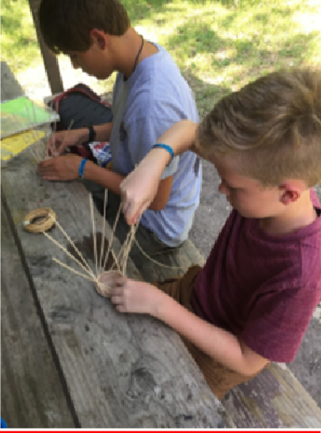
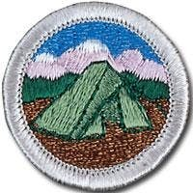
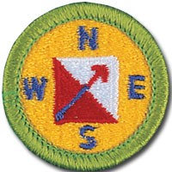
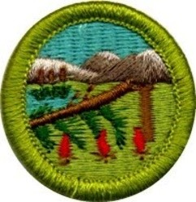
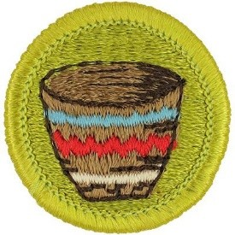
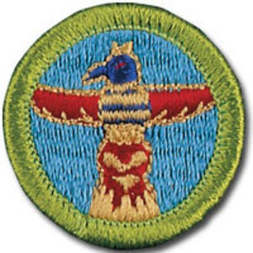
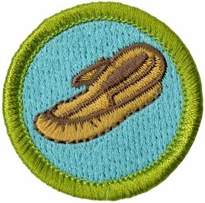
Outdoor Skills/Handicraft
The Outdoor Skills area is the cornerstone of outdoor & Scout skills at summer camp. Anyone hoping to become an Eagle Scout can surely tell you about the amount of time spent perfecting their knots and building pioneering projects.

Merit Badges
- Camping MB
- Geocaching MB
- Wilderness Survival MB
- Pioneering MB

Handicraft
Handicraft will be open during 3rd session and will be an open session. Scouts participating in Handicraft will sign up for two of the three Merit Badges offered. If they would like to finish a third Merit Badge, they will need to purchase a kit from the Trading Post.

Merit Badges
- Basketry MB
- Leatherwork MB
- Woodcarving MB

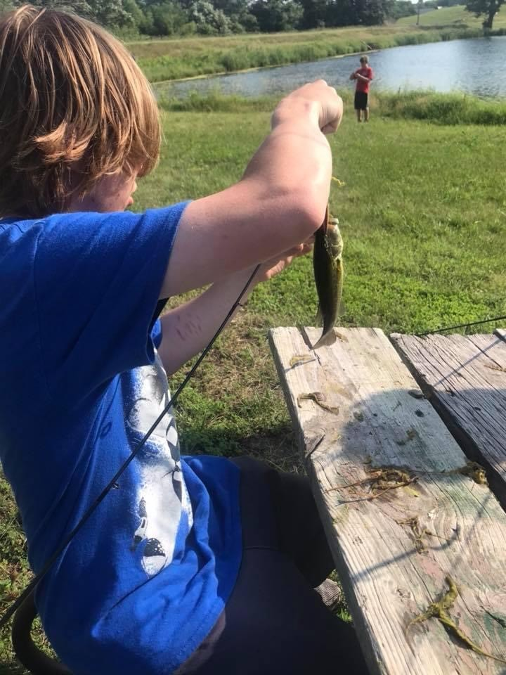
Ecology & Conservation
No matter what you call it, Ecology and Conservation (or Nature) is an important part of every summer camp. Ecology Merit Badges teach Scouts many different aspects of caring for our planet and everything on it.

Merit Badges
**Please note these merit badges are on a yearly rotation**
- Environmental Science
- Reptile & Amphibian Study
- Fly Fishing
- Bird Study
- Space Exploration/Astronomy
- Forestry
- Plant Science
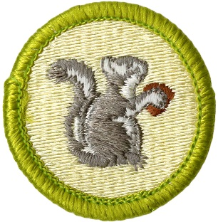
- Mammal Study
- Fly Fishing

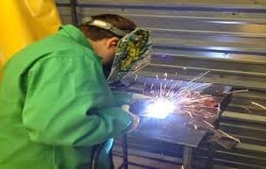
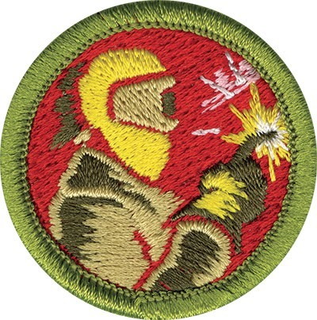
Technology/STEM
Our Technology area is a hidden gem at Camp Cornhusker. This unique program area provides unique opportunities for scouts. In their merit badges, Scouts will work hands on to design, create to set up experiments, make movies, and even explore space! The STEM area takes concepts taught to scouts in their school, and gives them an opportunity to study the concepts in experiments.

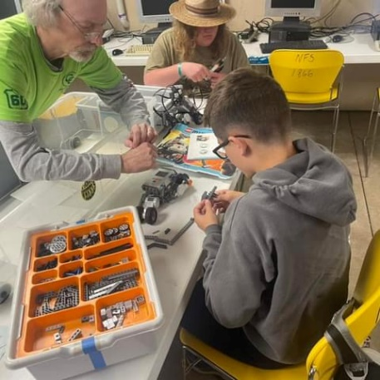
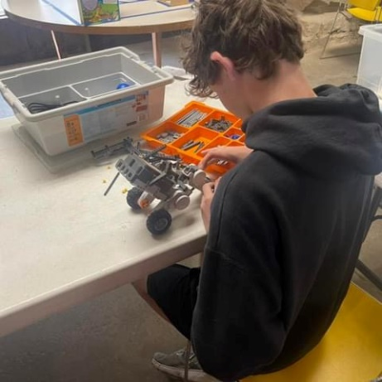
Merit Badges
- Engineering
- Digital Technology
- Robotics
- Photography

Life Skills
Check out our six bay building to teach the boys about the trades. Each bay has a separate merit badge, welding, auto maintenance, home repairs, electricity, electronics, farm machinery and plumbing.

Merit Badges
- Welding
- Electricity
- Electronics
- Plumbing
- Automotive Maintenance/Farm Mechanics

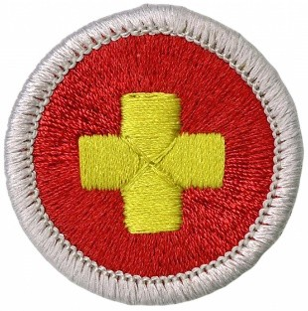
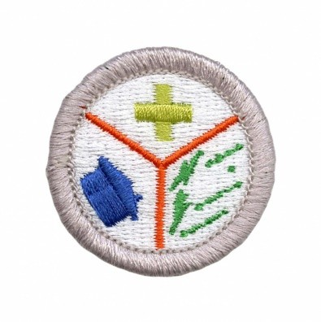
Health
The Health Program Area teaches Scouts the essential skills of First Aid and Emergency Preparedness. Scouts will work on identifying different injuries, practice their skills, and have the tools necessary to be prepared during an emergency.

Merit Badges
- Emergency Preparedness
- First Aid
- Public Health

Scout Skills
The Scout Skills area teaches scouts the essentials of good citizenship and communication.

Merit Badges

- Citizenship in the Nation
- Citizenship in the World
- Communication

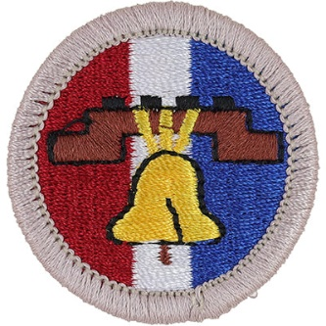

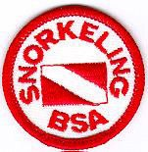
Opportunities for Older Scouts
Are your older Scouts looking for a non-traditional Merit Badge adventure? Scouts can choose different High Adventure activities to include in their schedules such as COPE, Cornhusker Sharp Shooters, Mountain Man, Snorkeling, and ATV. These are just a few great opportunities for older Scouts!

ATV at Camp Cornhusker
Grab your goggles and get ready to embark on one of Cornhusker’s premier high adventure programs! Participants in the Cornhusker ATV Experience will learn how to safely operate an ATV and explore Camp Cornhusker in the process. Scouts will also learn care and proper maintenance of safety equipment and ATVs, safety procedures of the ATV, and respect for the environment.
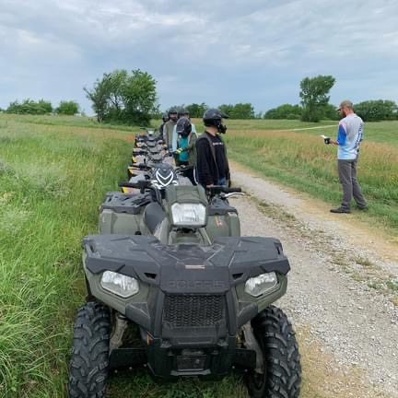
- Participants MUST be 14 years of age as of Monday the week they start camp.
- In order to participate, individuals are REQUIRED to fill out an ATV Hold Harmless Agreement as well as complete online safety class prior to attending camp.

- All Scouts must wear long sleeve shirts, long pants, closed toed shoes

- Gloves, goggles and helmets are provided but scouts are encouraged to bring their own.

- There is an additional fee of $25 to participate in this program.

*Subject to change based on availability of machinery*

Snorkeling

Completion of this course entitles the participant to receive and wear the Snorkeling BSA patch. Participants will learn proper fit and use of snorkeling equipment, entries and exits, signaling, survival skills, and Safe Swim Defense. While the camp has needed equipment, Scouts are encouraged to bring their own if they have some. This course is limited to 10 participants.

*You must be a Swimmer to take part in Snorkeling.

Cornhusker’s Sharp Shooters
The Cornhusker Sharp Shooters Program is for Venture Crews and Venture aged Scouts. This exciting program is available each week at camp on Monday and Tuesday. This action-packed shooting program option is for older youth who are looking for an exciting adventure while at camp. Participants in the program will get to engage in the following activities:
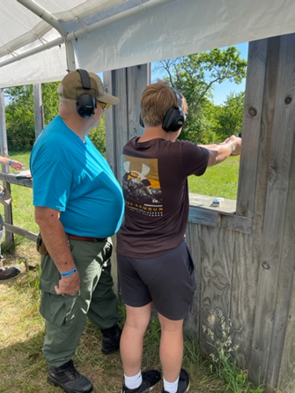
- Pistols, black powder, small and large bore rifles and 3D and action archery games.
Individual Scouts of Venturing age (14+) and Venture Crew members need to register just as they would for Scouts, BSA Resident Camp but instead of registering for merit badges; they will simply partake in the Cornhusker’s Sharp Shooters program. Additionally, youth not already in a Venture Crew will need to register as a Venture Scout with the standard BSA youth application or adult application for those 18 or over.
Please Note: There is an additional fee of $50.00
Crew size is limited to 10 per crew

C.O.P.E.
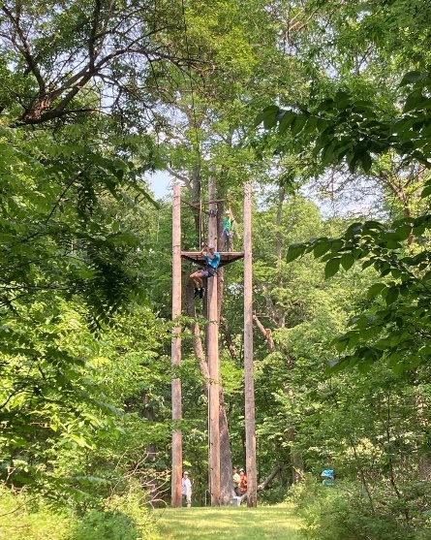
C.O.P.E. (“Challenging Outdoor Personal Experience”) is a national program of the Boy Scouts of America, which comprises of a series of outdoor challenges, beginning with basic group initiative games and progressing to more involved, complicated low-course and high-course activities.
There are activities that challenge the entire group of participants, while others develop individual skills and agility. Participants climb, swing, balance, jump, rappel and devise solutions to a variety of problems. Most participants achieve much more than they imagined possible. With a team building emphasis, this program shapes leaders and sends them back to your troop with more confidence and stronger leadership skills.

THERE IS A CLASS SIZE MINIMUM OF 6 PARTICIPANTS FOR C.O.P.E.
TO RUN.

Trail to First Class
Trail to First Class (TTFC) is a week of hands-on activities for first year Scouts. The TTFC program gives Scouts the best foundation for their Scouting future.
During the week, Scouts will participate in both troop and patrol meetings, led by trained adult leaders. Scouts will also learn the meanings of the Scout Oath and Law. Skills such as using a knife, hatchet, and saw to make tinder and kindling so they can start the fire with flint and steel will also be taught. Scouts will also learn their knots and how to build a useful camp gadget with lashings. Leaders will show Scouts how to use a compass and go on day compass courses. They will learn how to tell directions with a watch and to put a stick in the ground.
The TTFC Program covers requirements Tenderfoot, Second Class, and First Class. If Scouts would like the swimming and first aid requirements completed, they are welcome to take those merit badges in the afternoon.

The items needed for Leaders and Scouts each day can be found below:

- Monday: Knot Tying Rope, Knife
- Tuesday: Knot Tying Rope, Knife & Compass
- Wednesday: Knot Tying Rope, Knife, & Compass,
- Thursday: Knot Tying Rope, Knife, Compass, & Mess Kit
- Friday: Knot Tying Rope & Compass

TTFC will run all 5 days of the week. Program will wrap-up Friday morning.

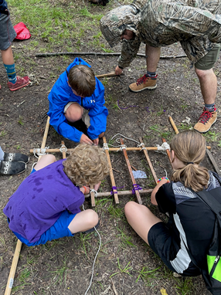
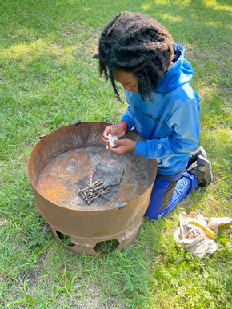

Mountain Man Program
The “Mountain Man” Program is Camp Cornhusker’s retention program. The goal of this program is to create a true sense of loyalty to Camp Cornhusker and the high ideals of Scouting, outdoor program and heritage for which it has stood since the camp’s creation in 1956.
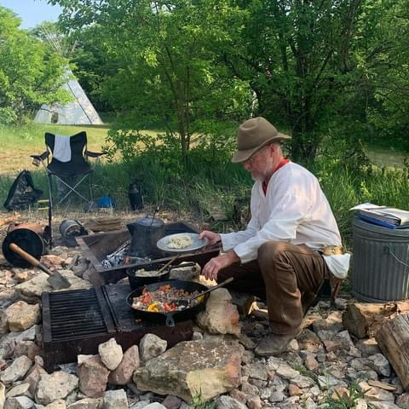
The Mountain Man Program is broken down into five distinct levels, based on years at Cornhusker
1st Year: Pioneer
2nd Year: Explorer
3rd Year: Frontiersman
4th Year: Voyager
5th Year: Mountain Man
Participants will spend time out at the outpost learning what life on the frontier was like in the 1800s. They will cook their meals over a fire, sleep under the stars, practice their forging skills, and craft Indian Lore.
While participation in the Mountain Man Program does not begin until your 3rd year at Cornhusker, first and second year campers will be able to experience parts of the Mountain Man Program throughout their week at camp.
PLEASE NOTE:
- Participants in their 3rd year (Trial of the Frontiersman) will spend their evenings out on the frontier. They will head back into main camp each morning to take Merit Badge Courses. These participants will need to sign-up for Merit Badges. They will be back in main camp before the 1st session begins.
- Participants in their 4th/5th year (Voyager/Mountain Man) will spend their week out on the frontier. They will have an option to participate in some other activities around camp towards the end of the week.
  - Monday-Tuesday: During the day, Scouts will participate in Cornhusker Sharpshooters. They will return to main camp for showers before heading back to the frontier for evening program.
  - Wednesday-Friday: Scouts have the ability to participate in other high adventure activities during the day before returning to the frontier for evening program. These include:
    - Golf Merit Badge (1 day)
    - Canoeing/Kayaking Excursion (1 day)
    - Biking Excursion (1 day)
    - COPE (1 day)
*These activities will take place based on the number of participates signed up.

The GEE-GAW is the recognition part of the Mountain Man program and designates the achievements of both Scouts and leaders at camp. First time campers at Cornhusker will receive their blank Gee-Gaws and year beads at Rendezvous. Returning campers please do not forget to bring your Gee-Gaw back to get it updated!

Year at Camp | Mountain Man Rank | Gee-Gaw Recognition
Year 1 | Pioneer | Blank Gee-Gaw Hide
Year 2 | Explorer | Mountain Stamp on Gee-Gaw
Year 3 | Frontiersman | Crossed Rifles Stamp on Gee-Gaw
Year 4 | Voyager | Special Black Bead
Year 5 | Mountain Man | Special Silver Bead
Year 6 and Up | Council of Wisdom | Special Glass Bead

Please refer to the separate Mountain Man Guide located on the Council Website for all details on the program and all its meaning. It also includes the instructions for making sure your youth are properly recognized.
Learn more at: https://www.cornhuskercouncil.org/camping/scouts-bsa/scouts-bsa-resident.html

The Long Tooth Circle
The Long Tooth Circle (LTC) is Camp Cornhusker’s adult alumni association organization. The Long Tooth Circle camp meeting will take place Wednesday night during Rendezvous. Only the members of the Long Tooth Circle will gather and go through the ceremony, which stresses the ideals of Scouting. Helpful suggestions will be aired concerning camp operations for that week and taken into consideration by the camp staff. Advancement may be awarded at this time and new members admitted.
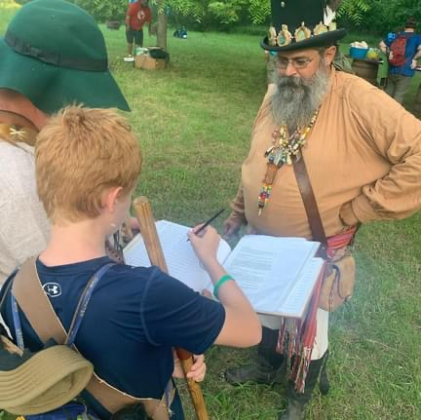
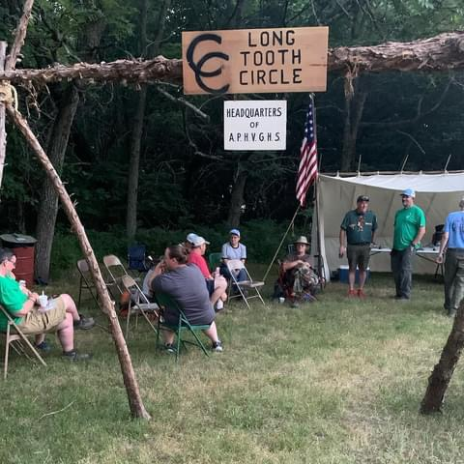
Learn more at http://www.cornhuskercouncil.org/support-scouting/long-tooth-circle/

Camp-Wide Activities/Games

Staff Hunt (Monday Free Time)

Scouts will search for staff members hidden throughout Camp Cornhusker

Game & Movie Night(Monday PM)

Monday Night is Troop Night/Movie Night. Take advantage of the Camp-Wide Games Area or check out a tote with board games/activities. A movie will close out the night!

Chapel Program (Tuesday AM)

Scouts are encouraged to attend our interfaith Chapel service Tuesday morning at 6:45 AM. Those attending the service will receive the chapel bead for their Gee-Gaw.

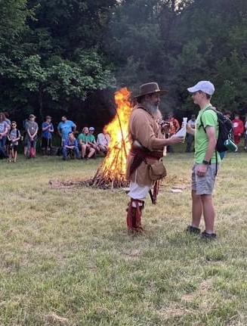
Disc Golf Tournament (Tuesday Free Time)

Teams will compete in our Disc Golf tournament!

Volleyball Tournament (Tuesday PM)

Head down to the Volleyball Court and participate in our volleyball tournament. The winning team will challenge the staff!

Rendezvous & Woodman’s Games (Wednesday)

The Rendezvous & Woodman’s Games is part of the Mountain Man Program. New Scouts and Leaders will receive their Mountain Man Gee-Gaws, while returning Leaders and Scouts will receive their year beads. There will be some new activities for Scouts to participate in at Rendezvous. The highlight of Rendezvous is trading! Scouts are encouraged to trade patches and other knick-knacks with other Scouts.

NOTE: There is no trading of knives, money, or food.

Dutch Oven Cook-Off (Wednesday)

The Dutch Oven Cook-Off will take place during Rendezvous on Wednesday night. Dishes are to be made at the unit’s campsite as part of cook-in campsite night and a sample to be brought to Rendezvous. This will be a blind taste testing! Hints for the secret ingredient will be given on the Camp Cornhusker Facebook page or at your district roundtables. We have had some fantastic entries over the years and are excited for this upcoming summer!

Banana Relay (Friday PM)

The banana relay is a Cornhusker tradition! The SPL from each Troop will work with the Program Director at the SPL Meetings to plan the relay. The banana will make its way around Camp Cornhusker and a Scoutmaster from each Troop will eat the Banana at the end of the relay!

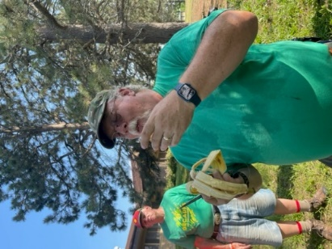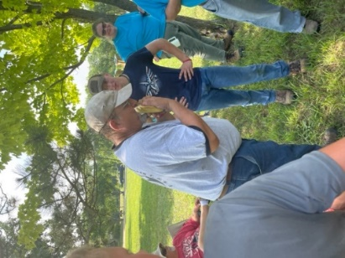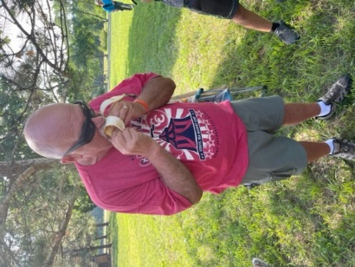
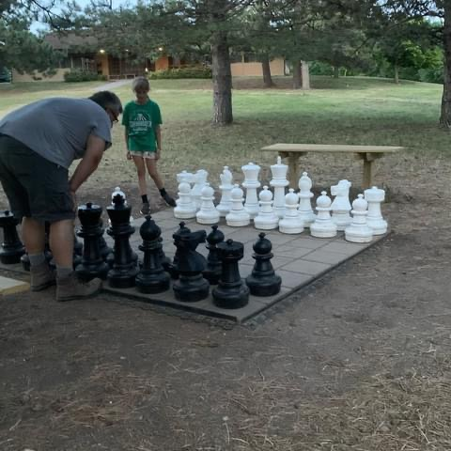

Camp-Wide Games Area
Games are always an option at Camp Cornhusker. The Cornhusker Games Area includes many opportunities to play/compete as a Troop. Included in the game area is the Ga-Ga Pit, 9-Square, Carpetball, Chess Tables, Life Size Chess, Cornhole, Ping-Pong, and Tetherball. It is available anytime, just make sure you check out the equipment at the Trading Post when you are ready to play. Huge kudos to the Golden Sun Lodge for this area!

Campfire Programs (Sunday & Friday)
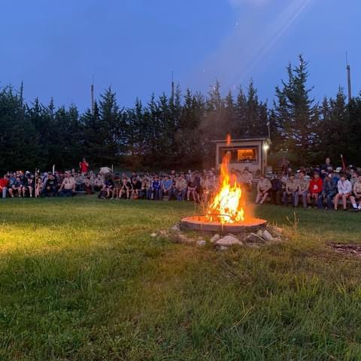
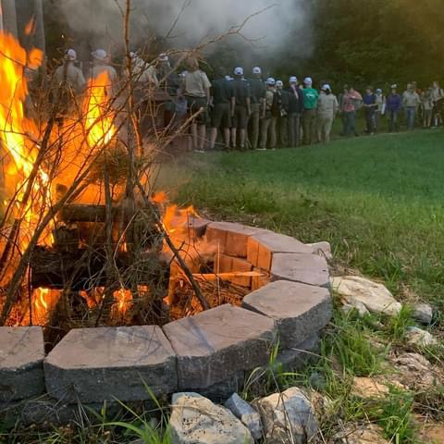
A staple of any summer camp experience is the opening and closing campfires! Our staff takes pride in being able to put on a fantastic show of skits, songs, and stories at the opening campfire on Sunday night, to get campers excited for the week ahead! After a fun and exciting week at camp, units will then put on their own production at the closing campfire on Friday night. Senior Patrol Leaders will work with the Program Director to plan the festivities for Friday night. Special awards and recognition will also be given at Friday night campfire.

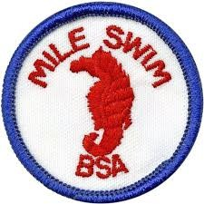
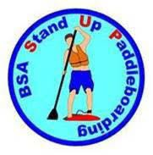
Mile Swim
Mile Swim practice will take place Monday-Thursday at 6:00 AM. On Friday morning, participants will swim the full 1600 meters. The BSA MILE SWIM exists to encourage swimming skills and recognize Scouts who swim one mile or more.
*Please note: must meet “Swimmer” requirements to participate.

Penguin Club
Another Cornhusker staple is Penguin Club! Each morning at 6:00 AM, Scouts are welcome to brave the chilly waters of the Lakefront. Each brave Scout or Scouter who gets wet 4 of the 5 weekdays of camp, becomes a member of this elite club and is duly recognized by the famous Penguin Club patch at no extra cost to the camper.
*Adjustments will be made if the weather does not cooperate*
**All swimming abilities are invited to attend**

The BSA Stand-Up Paddle Boarding Award
Introduces Scouts to the basics of stand-up paddle boarding (SUP) on calm water, including skills, equipment, self- rescue, and safety precautions. This award also encourages Scouts to develop paddling skills that promote fitness and safe aquatic recreation.
*Please note: must meet “Swimmer” requirements to participate.

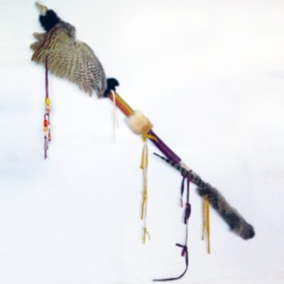
Honor Troop Requirements (Must meet 13 of 15 requirements)
- Have a representative at all SPL meetings.
- Have a representative at all leader meetings.
- Troop participates in flag ceremony at least once.
- All fees are paid (on time)
- At least one adult leader participates in the Scoutmaster Merit Badge
- Complete a service/conservation project while at camp or during a pre-camp Beaver Day
- Campsite inspection points (minimum 480 points)
- Troop participates in the Banana Relay
- Invite another troop to your campsite for fellowship (share a snack, games, etc.)
- Carry your Troop Flag to meals (minimum 4 times)
- Attend the OA Call Out Ceremony
- Have 1 skit or song for Friday night campfire.
- Troop leads a song at an assembly or in Dining Hall
- Troop participates in at least 3 of 6 camp wide activities.
- Troop attends Chapel Service

The “Spirit Stick”
At lunch each day, the Staff will vote on the troop that shows the most spirit in camp. The winning troop must affix a small totem to the Spirit Stick, which indicates they earned the stick for the day. At the closing campfire on Friday, the Spirit Stick will go home with the Troop that has shown exemplary spirit throughout the entire week.

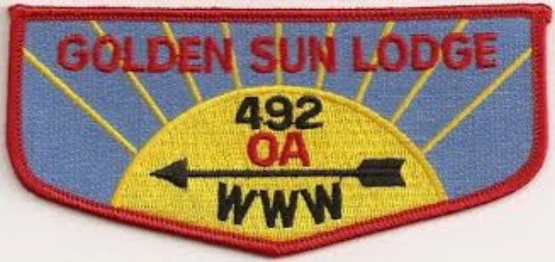
Order of the Arrow
The Order of the Arrow is Scouting’s national honor society, built around the lore of the Native Americans and the ideals of Scouting brotherhood, cheerful service to others, and the outdoors. Its purpose is to recognize those Scouts and Scouters that exemplify the Scout Oath and Law.
Membership requirements include:
- Unit leader approval
- Within the last two years, experience 15 days and nights of camping according to the standards of the Boy Scouts of America, five of which must be consecutive nights under the guidance of the Boy Scouts of America.
- Be a First Class Scout or above and be elected by the youth of the unit
- A Lodge Unit Election Team must conduct Unit Elections. For more information, you may contact the Golden Sun Lodge or your local council.
Thursday is OA day! We encourage you to wear either an OA Shirt or your Field Uniform with your sash all-day. The OA flag will be flown on Thursdays, as well.
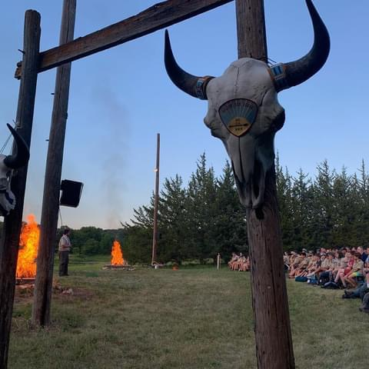
An Order of the Arrow Call Out Ceremony will be every Thursday night beginning at 8:30 PM in the Council Fire Ring. Troops will assemble in their campsites at 8:00pm and will wait for their OA guide to bring them to the ceremony. Be sure to bring and wear your sash!

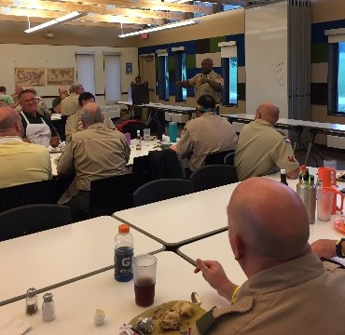
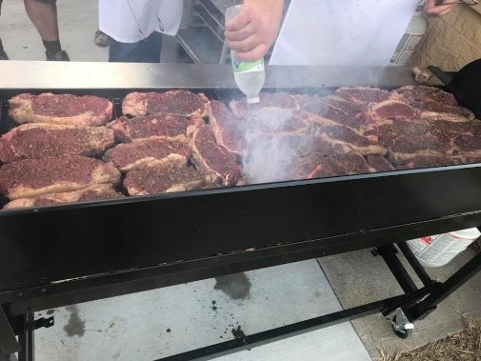
Adult Leader Opportunities

Scoutmaster Steak Dinner
On Tuesday night, Camp Cornhusker invites adult leaders to attend a steak dinner in the Korff building. Leaders can enjoy steaks cooked by the Council Executive Board members and other key Scouting professionals. This is a time to relax and enjoy fellowship with other leaders as the Camp Administration and the Council say thank you for your dedication to Scouting.

Senior Patrol Leader Meetings
Senior Patrol Leaders will have a working breakfast each morning with the Program Director in the Korff Building. During this time, important information will be shared about daily activities/events. Senior Patrol Leaders will also spend the week planning the Banana Relay for Friday.

Adult Leader Meetings
Adult leader meetings are held Sunday, Monday, Tuesday and Thursday at 1:30 PM in the Korff building. Information will be shared by the Camp Administration.

Scoutmaster Merit Badge
Leaders participating in the Scoutmaster Merit Badge have to complete a variety of tasks to earn the Cornhusker Scoutmaster Merit Badge. Please look over the information at the end of the Program Guide for more details.

Scouts, BSA Intro to Outdoor Leader Skills (IOLS)
This is a hands-on training program to help adult leaders to be comfortable in the basic outdoor skills through First Class rank. The course is held daily after lunch down in TTFC. Participation all five days is required for completion. This course is a required training for Scoutmasters and their assistants to be considered trained. The first session is Sunday night at 7:00 pm.

Training Opportunities
**These trainings are held Monday, Tuesday, and Wednesday Afternoons at 4:15pm** (topics subject to change based on Council Commissioner and volunteers available)

Leave No Trace Training- Monday
The Leave No Trace program instills in Scouts and Scouters an outdoor ethic that encourages responsible use of the outdoors, an ethic that reaches to the core mission of the Boy Scouts of America.

Safety Afloat & Safe Swim Defense- Tuesday
These two trainings are designed for leaders who are interested in gaining a better understanding of BSA Aquatics policy as it applies to swimming and boating activities.

Nap on Safely Training- Wednesday

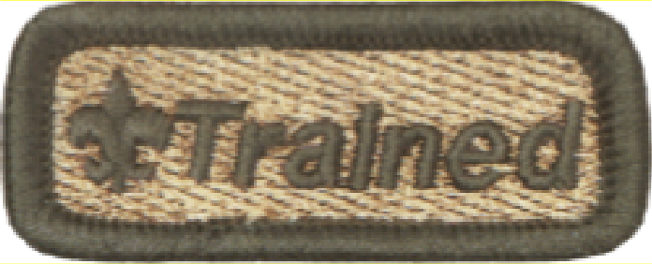
Please bring a pillow and chair to get an overview of the role of rest/sleep in Scouting and life.

Camp Equipment and What to Bring to Camp

Need to Have:
- Scout Uniform
- Clothing for 7 days and 6 nights including: underwear, socks, shirts, long pants, shorts, sweater/jacket, swim trunks, appropriate shoes
- Bring an extra pair of old beat up shoes for messy kicking around camp
- Toilet kit including: washcloths, towels, comb, toothpaste, toothbrush, soap, deodorant
- Insect repellent
- Sleeping bag or blankets and pillow
- Cot or ground cloth
- Rain gear or poncho
- Canteen or water bottle
- Wallet and money
- Scout Handbook
- Merit Badge pamphlets
- Pen, pencil and notebook
- Current medical form
- Flashlight and extra batteries
- Two garbage bags
- Camera- if taking Photography Merit Badge
- Water Shoes- Aquatics Merit Badges/Activities

Trail to First Class Participants and Adults Attending IOLS Need:
- Compass
- Pocket Knife
- Watch
- Metal Mess kit (Plate, Cup, Knife, Fork and Spoon)
- Rope
*Label all clothing and equipment with Scouts name and Troop number.*
Unit Equipment
All equipment necessary for cooking both for the Dutch Oven Cook Off and the cooking in campsite for Wednesday dinner.

Campsite Equipment
Each troop’s campsite includes a flag pole, fire pit, carport style shelter and water hydrant.

Staffing at Camp Cornhusker
If you have completed everything Cornhusker has to offer or love giving back to Scouting, we encourage you to come work on Camp Staff! Your knowledge and expertise are valuable as we continue making the Cornhusker experience the best it can possibly be!

General Camp Staff Information
- Staff must be eligible and willing to be a registered member of the Boy Scouts of America.
- Age requirements:
  - Counselor in Training (CIT I) – 14 years old by June 1 of the current camping season.
  - Counselor in Training (CIT II)– 15 years old by June 1 of the current camping season.
  - Directors / Counselors – 18 years of age or older by June 1 of current camping season.
  - BSA standards require some positions to be a minimum of 21 years of age, by June 1 of current camping season.
- The principles of the Scout Oath and Law must be practiced as a way of life. Staff is expected to set the highest example of excellence in Scouting.
- Housing and meals are provided. Staff is expected to maintain living quarters properly and always be in attendance at mealtime.
- References are important and will be reviewed as part of the selection process. Have your references complete the enclosed forms and return them directly to camping services at the address listed below. Applicants under 18 years of age must have one reference form completed by their Scoutmaster.
- Apply at any time. However, applications received by December 1st will receive first consideration.

One benefit of working on Camp Staff is the Camp Staff Scholarship. Staff members who complete their contract in good standing, are eligible to apply for this Scholarship.
Applications can be found on the Camp Cornhusker section of the Cornhusker Council website https://www.cornhuskercouncil.org/camping/camp-cornhusker/camp-staff.html. Applications can be emailed to campcornhuskerbsa@gmail.com.
Applications can be dropped off or mailed to the Outdoor Education Center:
Cornhusker Council
PO Box 269
Walton, NE, 68461
For more information on staffing summer camp or the Camp Staff Scholarship, please visit the Camp Cornhusker section of the Council Website or contact Sammi Lowery, Camp Director, at campcornhuskerbsa@gmail.com or Thomas Bucks, Program Director, at cornhuskerprogramdirector@gmail.com.

Cornhusker Honor Camper Award

The Honor Camper Award rewards those youth who participate to the fullest extent possible in the Camp Cornhusker program. Honor Campers Awards are limited to two campers per unit. Youth who complete 15 of the 20 requirements and receive staff signatures confirming this will be eligible for the award. Form is due to the Program Director by dinner on Friday. Unit leaders please assist us in verifying this information is correct.

- Achieve Swimmer on the swim test
- Learn the middle name of four staff members _________, __________, ________, _______
- Take out a Canoe or Rowboat in the Aquatics Area (excludes Merit Badge class)
- Assist with a Service Project
- Beat a member of the staff in ping pong
- Go to Outdoor Skills or TTFC and tie a bowline in under 3.5 seconds
- Go to Ecology and identify 5 plants
- Go to Health Pavilion and be able to correctly perform CPR
- Attend each evening Flag Ceremony in complete Class A uniform
- Be a table waiter in the Dining Hall for your unit for at least 2 meals
- Invite a staff member to your campsite for a campfire or other in-campsite activity
- Attend Chapel Service
- Find a Staff Member who has been to Philmont, Northern Tier, or Sea Base and talk to them about their experience
- Ask a staffer how to work on staff at Camp Cornhusker
- Live by the Scout Oath/Law each day at Camp
- Participate in any 4 camp-wide activities
- Participate in COPE, Cornhusker Sharpshooters, Mountain Man, or ATV
- Challenge a staff member to a game of rock, paper, scissors. Win two out of three games
- Tell a joke to the Program Director or Camp Director
- Get the Camp Cornhusker brand on something you own

Scoutmaster Merit Badge
Complete 15 of 20 requirements and receive a signature by staff. Form is due Friday to the Program Director.
- Hold a current Youth Protection Card- FREEBIE!
- Take a nap in a new spot at camp (must provide photographic documentation)
- Attend Opening Campfire on Sunday Night
- Attend Thursday night Order of the Arrow Call Out.
- Attend Chapel
- Participate in the Mile Swim or Penguin Club.
- Assist the Ranger with a work project
- Attend one Adult Leader Training.
  - Leave No Trace
  - Safety Afloat
  - Safe Swim Defense
  - Nap on Safely
- Turn in an Adult Leader Evaluation.
- Visit each program area. Must have all to earn this one.
  - Shooting Sports
  - Aquatics
  - Ecology/Nature
  - Outdoor Skills/Handicraft
  - C.O.P.E.
  - Life Skills
  - Scout Skills
  - Technology
- Assist with the teaching of a merit badge
- Attend the Scoutmaster Steak Dinner.
- Visit the Office and pick up mail.
- Challenge a staff member to ping pong or cornhole AND beat them
- Shoot a score of 50 at the archery range (4 ends)
- Visit Outdoor Skills or TTFC and tie the each knot in five seconds or less
  - Two-Half Hitches
  - Clove Hitch
  - Square Knot
  - Bowline
  - Taut-Line Hitch
- Take a Canoe/Rowboat out at the Aquatics Area
- Get an object branded (walking stick, mug, hat, etc)
- Visit the Health Pavilion and correctly perform CPR
- Help Take out the Trash at the Dining Hall

Adult Leader Name: _______________________________ Unit # ___________

Campsite:

